SCHEDULE, SCOPE & RESOURCE · VITALIS THERAPEUTICS INC.
Integrated Development Schedule
Vitalis Therapeutics Inc. · VitaFlow (VTX-401) · Integrated Development Schedule · status 15 October 2026. Fictional program.

1. What an Integrated Schedule Is For
Three tracks run this program and only one of them can be the reason the filing slips. The clinical track produces the evidence, the CMC track produces the product, and the regulatory track produces the submission — and they are managed by different functions, on different logic, against the same date. An integrated schedule exists so that the dependency between them is visible, because that is where the slip comes from.
 | Value
Program span | Mar 2022 – Nov 2029 (7.6 years to approval)
Activities | 39 — 27 bars, 12 milestones
On the critical path | 29 of 39
Carrying float | 10
Speaks as at | 15 October 2026 — anything to the right of the amber line is forecast

29 of 39 activities sit on the critical path.
On most programs that ratio would be a planning failure — it usually means the network has been drawn as a single chain because nobody worked out what could run in parallel. Here it is the honest shape of the problem. Drug development is overwhelmingly serial: you cannot run Phase 3 before Phase 2 has selected a dose, you cannot select a dose before participants have been treated, and you cannot treat participants before an IND is in effect. Float is the exception in this program, not the rule, and the ten activities that carry it are almost all CMC.
2. The Schedule
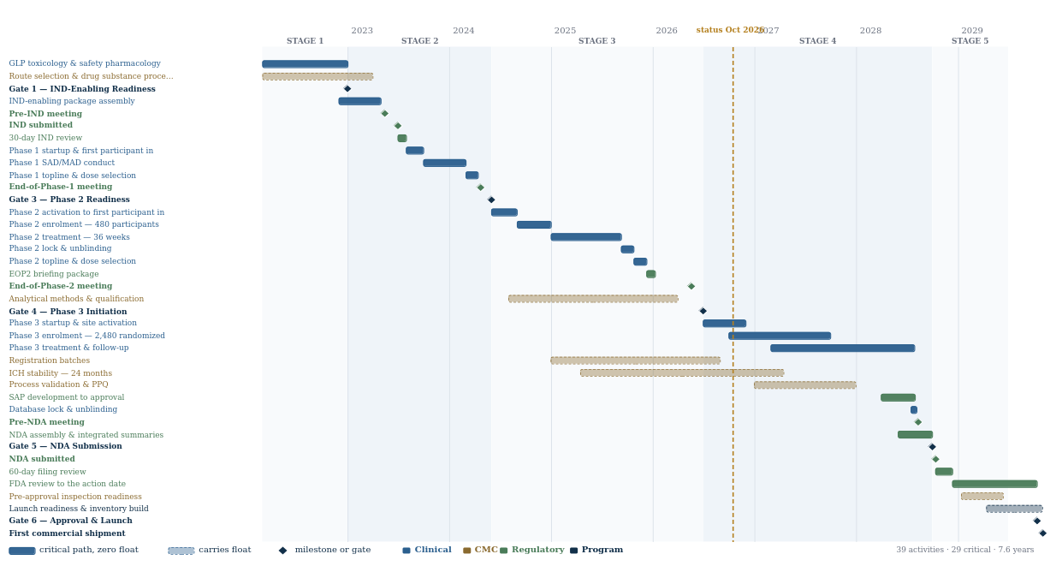
Every bar is derived from the gate dates rather than typed in. That is a deliberate construction: the whole front end of this program was re-dated on 29 July 2026, and a schedule built from literal dates would have needed thirty-nine manual edits and would have been wrong in at least one of them. Changing one constant moves the entire chart, and the reconciliation contract below re-checks itself on the way.
Track | Activities | of which milestones | On critical path | Span
Clinical | 14 | 0 | 14 | Mar 2022 – Aug 2028
CMC | 6 | 0 | 0 | Mar 2022 – Jun 2029
Regulatory | 12 | 6 | 9 | May 2023 – Oct 2029
Program | 7 | 6 | 6 | Dec 2022 – Nov 2029

The CMC track is the one to look at twice. It has the most float and the least attention, and it is the track that gates the filing independently of everything the clinical track does. A filing date is a manufacturing date as much as it is a data date.
3. The Critical Path, and Where It Changes Hands
The critical path runs the length of the program, but it is not held by the same function throughout. Naming the handovers is more useful than naming the path.
Period | Critical path sits with | Because
Mar 2022 – Jun 2023 | Nonclinical | Nothing can be dosed in a human being until the GLP toxicology package supports it. The IND is an assembly job; the tox program is the long pole.
Jun 2023 – May 2024 | Clinical — Phase 1 | Dose selection gates everything downstream, and it cannot be accelerated by adding people.
May 2024 – Jun 2026 | Clinical — Phase 2 | The longest single stretch, and the one analyzed in §4.
Jun 2026 – Jul 2028 | Clinical — Phase 3 | 68 weeks of treatment on the last participant randomized. The critical path is not the trial; it is the last participant.
Jul 2028 – Oct 2028 | Biostatistics, then Regulatory | Lock, unblind, analyze, assemble. Roughly eleven weeks between the last data point and the submission, and the SAP has to have been signed before any of it.
Oct 2028 – Oct 2029 | The agency | The sponsor's remaining influence is entirely negative: it can slow the review and cannot speed it.

The critical path ends up somewhere the sponsor does not work.
For the last twelve months before the action date, the activity that determines the launch date is being performed by people at the agency, on a statutory clock, with the sponsor's role reduced to answering information requests quickly and not filing a major amendment. A program manager who has not planned for that period will try to manage it, and the only available actions all make it worse.
The corollary runs backwards through the whole chart: every month of schedule has to be won before the submission, because after it there are none to win.
4. Why Phase 2 Sets the Shape of the Program
Phase 2 is the longest continuous stretch on the critical path and the one most often underestimated, because its duration is set by biology rather than by resourcing. This is the arithmetic, and it is now enforced at build time rather than assumed.
Phase 2 step | Months
Site activation to first participant in | 3.0
Enrolment | 4.0
Treatment | 8.3
Database lock and unblinding | 1.5
Topline analysis and dose selection | 1.5
Briefing package assembly | 1.0
Total lead time required | 19.3
Window available — Gate 3 to the EOP2 briefing package | 22.6 | 3.3 months float

The binding constraint is not Gate 4. It is the End-of-Phase-2 briefing package, due 19 April 2026 — thirty days before the meeting, per the agency's own procedure. The meeting's agenda is pivotal design and dose selection, so the Phase 2 result has to exist when the package is written, not when the meeting is held. The real deadline sits a month earlier than the one in the calendar, and it is the one worth planning against.
This artifact exists because building it found the schedule was impossible.
Until 29 July 2026 this program ran Gate 3 to the briefing package in 7.6 months against a requirement of 19.3. Nothing flagged it, because every check in the suite tested money and identity rather than calendar. The End-of-Phase-2 meeting had an agenda built on data that could not have existed, and the Gate 4 business case rested on the same data.
The front end was moved fifteen months earlier and Gate 4 onward left untouched, which preserved the status date, the delivery arc and every end-state figure. The program is now 7.6 years to approval rather than 6.3 — which is also simply more plausible; a 505(b)(1) new molecular entity in six years would be remarkable rather than typical.
There is now a reconcile-or-fail check on the calendar, not just on the budget: if a future edit compresses the front end again, the fact base refuses to import and nothing in this suite builds.
It cost something. Spending $75.4M fifteen months earlier against an unchanged launch date destroyed roughly $144,000,000 of net present value without changing a single cash amount. That number is the clearest statement in the suite of why schedule has financial worth, and it is worth carrying into any conversation about whether a program can “just start later”.
5. What Would Move the Filing Date
At the status date the program is in Phase 3 with the submission 24 months away. Three things can move that date, and they are not equally likely, equally visible, or equally recoverable.
Driver | Position at 15 Oct 2026 | Effect on the filing date
Phase 3 enrolment | 1,684 randomized against a curve of 1,760 — 76 behind. 231 of 260 sites activated; activation running 22 weeks against a planned 18. | One for one. Treatment duration is fixed at 68 weeks, so a month of slip in the last participant randomized is a month of slip in the last data point, database lock, and every date after it.
CMC readiness | Stability at 18 of 24 months; 2 of 3 registration batches; 2 of 3 methods re-qualified. Three of seven Gate 5 CMC criteria assessed at risk. | Independent, and it cannot be compressed. Stability runs on the calendar, not on effort. If CMC becomes the late track, no amount of clinical recovery helps.
Regulatory | Seven information requests answered; zero major amendments; the Pre-NDA meeting is scheduled for 10 Aug 2028. | Asymmetric. Nothing here can pull the date in. A major amendment after submission would push it by three months, and a refuse-to-file removes the clock entirely.

The enrolment shortfall is a schedule problem that cannot be solved with schedule levers.
76 participants behind curve does not sound like much against a target of 2,480. What makes it structural is where it came from: site activation is running 22 weeks against a planned 18, and the delay is in contracts and ethics review rather than in clinical work. Those are the two steps the sponsor influences least and the CRO cannot compel at all.
Adding monitors does not activate a site faster. Adding sites adds more of the same 22-week lead time before they contribute anything. The only lever that acts inside the current quarter is the reserve site list, and the recovery plan is deliberately forecast on it delivering half of what it promises — because forecasting full delivery is how a program reports green until the month it reports red.
Notice what the first column has in common. Every one of these three is a case where schedule can be lost; none of them is a case where it can be gained. That asymmetry is the single most useful thing to hold about a development schedule, and it is why the float in this plan sits almost entirely in the CMC track: float placed anywhere on the clinical critical path would already have been consumed.
The dates in this schedule beyond October 2026 are therefore not predictions in any strong sense. They are the dates the program is committed to and measured against, carrying a known set of exposures that are named above rather than buried in an optimistic single number. A schedule whose forecast never moves is not a stable schedule; it is one nobody is updating.
6. Milestones
Every dated commitment in the program. Nine have passed at the status date; the rest are forecast, and are shown as forecast rather than quietly presented as fact.
Date | Milestone | Status at 15 Oct 2026
31 Dec 2022 | Gate 1 — IND-Enabling Readiness | Past
14 May 2023 | Pre-IND meeting | Past
30 Jun 2023 | IND submitted | Past
22 Apr 2024 | End-of-Phase-1 meeting | Past
31 May 2024 | Gate 3 — Phase 2 Readiness | Past
19 May 2026 | End-of-Phase-2 meeting | Past
30 Jun 2026 | Gate 4 — Phase 3 Initiation | Past
10 Aug 2028 | Pre-NDA meeting | Forecast
30 Sep 2028 | Gate 5 — NDA Submission | Forecast
12 Oct 2028 | NDA submitted | Forecast
11 Oct 2029 | Gate 6 — Approval & Launch | Forecast
01 Nov 2029 | First commercial shipment | Forecast

Two of these are not the program's to move. The action date is set by statute from the filing date, and the filing date is set by the agency sixty days after submission. Every other date on this chart is a plan; those two are arithmetic performed by somebody else.
7. Excluded From the View
Not shown | Why
Site-level activity | 260 sites activate on 260 different contract and IRB timelines. Rolling them into one bar is the only honest option at program level; the detail belongs in the Site Management Plan.
The CRO's internal schedule | The program contracts deliverables and service levels, not activities. A sponsor schedule that pretends to know the vendor's plan is asserting oversight it does not have.
Resource-levelled bars | This is a logic schedule. Effort lives in the Resource Plan, and the two are deliberately separate: levelling a logic network hides which constraint is actually binding.
The failure branches | There is no bar for a failed pivotal, a refuse-to-file or a complete response letter. Those are not schedule slips, they are different programs, and they are handled at a gate rather than in a plan.

The most useful thing on this chart is the amber line.
Everything to its left is history and can be argued about with evidence. Everything to its right is a forecast made by people who are wrong about something and do not yet know which thing. The value of drawing it is not that the right-hand side is accurate — it will not be — but that it is committed, so that when it moves, the movement is visible and has to be explained.

