SCOPE & RESOURCE · VITALIS THERAPEUTICS INC.
Organization Chart & OBS
Vitalis Therapeutics Inc. · VitaFlow (VTX-401) · Organization Chart & OBS · status 15 October 2026. Fictional program.

Vitalis Therapeutics Inc. — Organization and OBS for the VitaFlow (VTX-401) program: 109 people across 10 functions of whom 4 report to the Program Director, the three reporting lines deliberately placed outside the program, where the OBS intersects the WBS to form control accounts, and the 83% of the work performed by organizations on no internal chart.
1. The Shape of the Problem
People inside the program | 109
Who report to the Program Director on a solid line | 4
Functions contributing | 10
Control accounts | 11
Share of budget delivered by organizations outside the company | 83.4%
Investigational sites — independent institutions | 260
Reporting lines deliberately outside the program | 3

The Program Director is accountable for $243,040,000 and line-manages four people.
That is not a resourcing failure. It is the normal and correct condition of program management in a functional organization, and it is the thing that makes the role a discipline rather than a title. Authority here is not positional. It comes from three places: a charter that says what the program may do, a gate process that controls money, and contracts that bind the 83% of the work nobody in the company performs.
A Program Director who tries to run this by instruction will fail. The instruments are the plan, the gate, and the contract.
2. Organizational Breakdown Structure
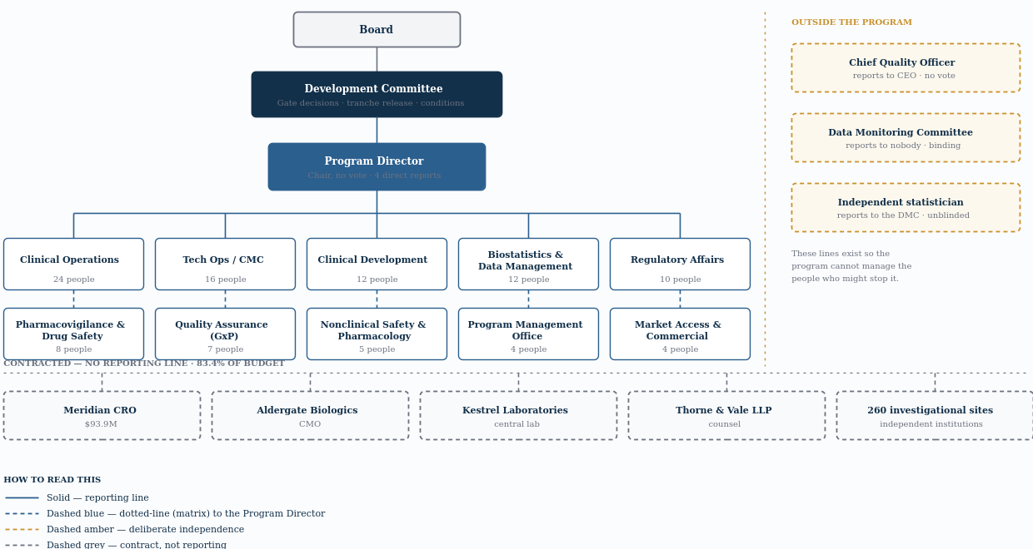
Unit | Reports to | Accountable for | Note
Board | — | Approves the ceiling; hears escalations that would exhaust reserve | Above the program entirely.
Development Committee | Board | Gate decisions, tranche release, conditions | Governance body, not a management layer. Meets at gates and on exception.
Program Director | Committee (as Chair, no vote) | Integration, plan, risk, reporting, vendor governance | Accountable for the program; line manager of almost nobody in it.
Function leads × 10 | Their function head (solid); PD (dotted) | Deliver their function's work packages | Matrix. The PD sets what and when; the function head sets who and how.
Chief Quality Officer | CEO — not the PD | GxP, audit, CAPA, inspection | Deliberately outside the program's reporting line.
Data Monitoring Committee | Nobody — independent | Participant safety; may recommend suspension | Binding on the program. Not appealable to the Committee.
Independent statistician | DMC | Unblinded analyses for the DMC | Reports to the DMC, not to the sponsor. Sees what nobody else may.

Read rows five, six and seven together — they are the most deliberate lines on the chart.
The Chief Quality Officer reports to the CEO, not the Program Director, and sits on the Development Committee without a vote. The Data Monitoring Committee reports to nobody and can recommend suspension that the Committee cannot overrule. The independent statistician reports to the DMC and sees unblinded data that the sponsor's own Chief Medical Officer may not see.
Each of those lines exists so that the program cannot manage the people who might stop it. As the Committee Charter records, four matters sit outside Committee authority entirely — and this chart is where that boundary becomes an organizational fact rather than a policy statement.
Note also what the Development Committee is not. It is not a management layer above the Program Director; it meets at gates and on exception. Between gates the program is run by the Program Director against an authorization the Committee already gave. Governance decides whether to continue; management decides how.
3. What the Program Director Actually Controls
With four direct reports and 83% of the work outside the company, the question is not what authority the role has but which instruments it holds.
Instrument | What it controls | Limit
The charter | What the program is permitted to do, and what is out of scope | Cannot be changed by the program — only by the Committee.
The gate | Money. No stage is funded before its gate carries, and tranches release against evidence | Between gates the lever is not available.
The contract | The 83% of effort performed externally — scope, KPIs, audit rights, transferred obligations | Slow. Changing a contract is not a management action.
The plan and the baseline | What is expected, by when, at what cost — and therefore what counts as a variance | Only as good as the estimates underneath it.
The register | What is written down as a risk, condition or assumption — and therefore what has an owner and a date | Records a problem; does not resolve it.
Escalation | The right to put a decision in front of the Committee | Spends credibility. Used too often it stops working.

None of those instruments is instruction, and that is the point. A Program Director cannot tell a function lead's team what to do, cannot direct a CRO's staff, and cannot tell an investigator which participant to screen next.
What they can do is make the expected thing visible, funded, contracted and owned — and make the unexpected thing escalate. A program that is well run looks, from outside, like one where nobody had to be told anything.
One instrument above is misused more than all the others together. Escalation is not a way of transferring a decision the Program Director should be taking; it is for decisions genuinely outside their authority — scope, ceiling, or a matter the charter reserves.
This program escalated three times outside gate meetings: the method transfer failure (I-02), the enrolment recovery reserve draw, and the launch supply build. Each was a ceiling or scope question. Everything else was decided inside the program and reported at the next checkpoint.
4. The Matrix
Function | Headcount | Reports to
Clinical Operations | 24 | Function head (solid) · Program Director (dotted)
Technical Operations / CMC | 16 | Function head (solid) · Program Director (dotted)
Clinical Development | 12 | Function head (solid) · Program Director (dotted)
Biostatistics & Data Management | 12 | Function head (solid) · Program Director (dotted)
Regulatory Affairs | 10 | Function head (solid) · Program Director (dotted)
Pharmacovigilance & Drug Safety | 8 | Function head (solid) · Program Director (dotted)
Quality Assurance (GxP) | 7 | Function head (solid) · Program Director (dotted)
Nonclinical Safety & Pharmacology | 5 | Function head (solid) · Program Director (dotted)
Program Management Office | 4 | Function head (solid) · Program Director (dotted)
Market Access & Commercial | 4 | Function head (solid) · Program Director (dotted)

Every function lead has two managers, and the split is cleaner than it sounds.
The function head owns who and how — who is assigned, how the work is performed, professional standards, career and capability. The Program Director owns what and when — which deliverables, to which dates, against which budget.
Conflict is a feature of that design, not a symptom of it. When a function cannot resource what the program needs, the matrix surfaces it as a visible negotiation between two accountable people rather than hiding it inside one person's judgment.
What the matrix does badly is speed. A decision that needs a function's people, a program's budget and a quality opinion touches three reporting lines. That is why the program carries a delegated draw authority (see the Contingency Register) and why the Committee meets on exception as well as at gates — both exist to stop routine decisions from queuing behind a governance calendar.
5. Where the OBS Meets the WBS
A control account is not a budget line. It is the intersection of a WBS node and an OBS unit — a piece of scope with one accountable owner.
Control account | Deliverable | Accountable function
1.1 | Nonclinical Package | Nonclinical Safety & Pharmacology
1.2 | CMC — Early Development | Technical Operations / CMC
1.3 | IND Package | Regulatory Affairs
1.4 | Phase 1 Clinical | Clinical Development
1.5 | Phase 2 Clinical | Clinical Development
1.6 | Phase 3 Clinical | Clinical Operations
1.7 | CMC Scale-Up & Validation | Technical Operations / CMC
1.8 | NDA Preparation & Review | Regulatory Affairs
1.9 | Regulatory Affairs | Regulatory Affairs
1.10 | Program Management | Program Management Office
1.11 | Advisors & Other | Program Management Office

Eleven control accounts, and only six distinct owners. Clinical Development owns two, the CMC function owns two, Regulatory owns three, Program Management owns two.
That concentration is deliberate. Splitting accountability finer would create more owners than the program can govern; leaving it coarser would create nodes where nobody can answer for the whole. The test is whether one named person can be asked “where is 1.7?” and answer without consulting anyone.
Note that 1.6 — 50% of the entire program — is owned by Clinical Operations, the function that manages sites but does not employ a single investigator.
The accountable owner of the program's largest control account is accountable for work performed by 260 institutions that do not report to them, under contracts, on their own timelines. That is the sharpest version of the problem this whole chart describes.
6. The Organization Outside the Organization
83.4% of the budget is delivered by entities that appear on no internal org chart.
Organization | Role | Contract value | Scope | Note
Meridian Clinical Research | CRO | $93,900,000 | Trial conduct, monitoring, data management, biostatistics | Largest single external relationship. Governed by contract and a joint operating committee.
Aldergate Biologics | CMO | — | Drug substance and product, packaging, labeling | Also the pre-approval inspection site — so its quality system is the program's exposure.
Kestrel Laboratories | Central laboratory | — | Sample analysis, reference ranges, data transfer
Thorne & Vale LLP | Regulatory counsel | — | Submissions review, agency correspondence, labeling
260 investigational sites | Independent institutions | — | Screening, randomization, dosing, follow-up | Not employees, not vendors. Each has its own IRB, contract and priorities.

The metaphor holds for four rows and then breaks. Sites are not employees and not vendors. Each is an independent institution with its own IRB, its own contract, its own competing studies and its own priorities. The program cannot direct them; it can only make participation attractive, administratively easy, and worth continuing.
Which is why the enrolment shortfall was never solvable by management attention. It was solvable — partially — by activating more sites, and that is a contracting and IRB problem, not a supervisory one.
For the CRO and CMO the instrument is different again. Execution is contracted; the obligation is not (21 CFR 312.52). So the program's control over $93,900,000 of CRO scope runs through a written transfer of obligations, a joint operating committee, defined KPIs and an audit right — not through a reporting line.
7. How the Chart Changes Over Time
Stage | Organizational shape
Stage 1–2 | Nonclinical and CMC dominant. Small clinical footprint. Nonclinical is near zero after Gate 2 and does not return.
Stage 3 | Clinical Development leads. Data management and biostatistics ramp.
Stage 4 | Peak. Clinical Operations at full size, CMC scale-up running in parallel, safety and data at maximum load.
Stage 5 | Clinical winds down; Regulatory and CMC carry the filing. Market Access staffs up last.
Post-approval | The program dissolves. Obligations transfer to permanent functions.

The last two rows contain the organizational cause of this program's largest outcome miss.
Market Access is the joint-smallest function in the program (4 people, level with the Program Management Office), the latest to staff, and the lowest hours per head of any function (1,250 against a roster average of 1,756) — and it carried the assumption with the longest lead time, because payer evidence has to be generated during Phase 3 to be usable at launch. The two smallest functions in a $243.0M program are the one that coordinates it and the one that carries its central commercial assumption.
GC-03 was the governance system detecting exactly this and being unable to fix it with a condition, because a condition can require evidence but cannot retroactively create the years of data collection that would have produced it. An organizational sequencing decision made at Gate 3 determined a commercial outcome in 2029.
The Closure Report records team release phased across the final two quarters rather than at closure — because a program that disbands on its closure date has nobody left to write the closure report.

