GOVERNANCE · VITALIS THERAPEUTICS INC.
Stakeholder & Communications Plan
Vitalis Therapeutics Inc. · VitaFlow (VTX-401) · Stakeholder & Communications Plan · status 15 October 2026. Fictional program.

1. The Map
Twelve stakeholders plotted on influence over the outcome against interest today. The color is the finding: blue is a relationship the program can manage, red is one it cannot.
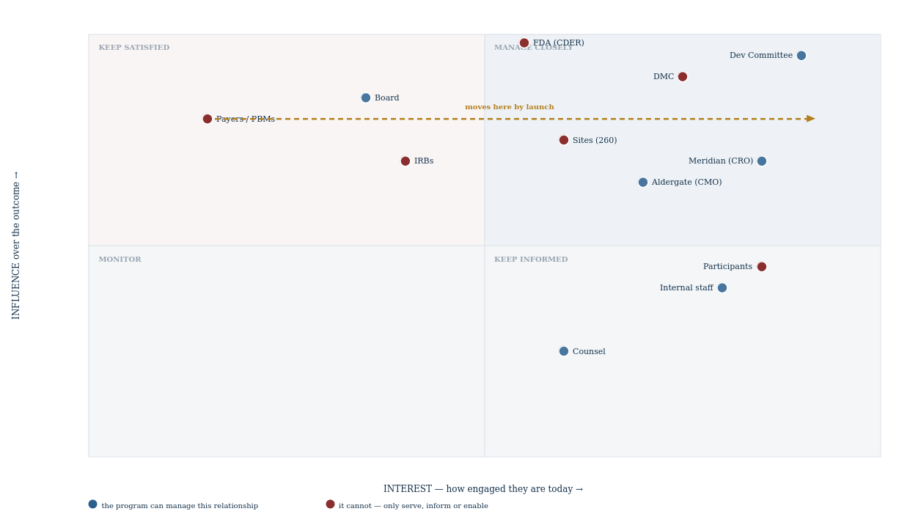
2. Where the Numbers Came From
A two-by-two map is the most opinion-driven artifact in program management, and almost nobody says how their positions were arrived at. These were scored against stated tests rather than by feel, and the tests are worth arguing with.
Axis | The test applied | Why not something softer
Influence | Can this party unilaterally stop, delay or materially change the program's outcome? Scored high only where the answer is yes without anyone else's agreement. | ⚠ “Importance” and “seniority” both inflate. The Board is more senior than an IRB and can stop the program far less easily than one can stop a site.
Interest | How much attention are they paying today, evidenced by contact frequency and by whether they initiate it. | Interest is observable. Asking how much someone cares produces the answer they think is expected.
Manageable | Is there a lever — contractual, financial or hierarchical — that changes their behavior? ⚠ Binary, deliberately. | A spectrum here invites “partly manageable”, which in practice means the program will try to manage something it cannot and will report progress on the attempt.

The weakness of this method is that it was applied by the program to itself.
Every score here is the Program Director's assessment, and a Program Director has a systematic reason to overstate influence over parties they are responsible for engaging. The DMC at 0.90 influence and unmanageable is easy to be honest about; the sites at 0.75 and unmanageable was harder, because it is an admission that half the program's cost sits with people nobody can direct.
The available correction is weak and worth stating: positions are re-scored at each gate, in front of the Committee, and a movement has to be explained. That does not remove the bias — it makes it visible over time, which is a different and lesser thing.
3. Five of the Eight Most Powerful Parties Cannot Be Managed
8 stakeholders sit at influence 0.70 or above. 5 of them are outside the program's reach entirely.
Party | Influence | Why it cannot be managed | What is possible instead
FDA (CDER) | 0.98 | ⚠ There is no informal channel. Everything said joins the file, whatever the answer. | Ask only questions you can act on either way; submit completely; never surprise them.
Data Monitoring Committee | 0.90 | ⚠⚠ Deliberately unmanageable. It exists so the program cannot manage the body that might stop it. | Charter it properly, resource it, and stay out of its way.
Payers and PBMs | 0.80 | They run a procurement on their own calendar and owe the sponsor nothing until there is a product to buy. | ⚠⚠ Engage years early, or accept whatever position the evidence earns.
Investigators and sites | 0.75 | 260 independent institutions with their own priorities and competing trials. Neither employees nor vendors. | Select well, activate fast, remove friction. Enthusiasm cannot be contracted.
Institutional Review Boards | 0.70 | Independent by design, on published calendars the sponsor may not influence. | Submit complete packages against their cut-offs, not against yours.

The trap this map exists to expose: a program manages the stakeholders it can reach, and the ones it cannot reach decide the outcome.
The Committee, the Board, the CRO and the CMO are all genuinely manageable, all genuinely important, and all get the bulk of the attention because engagement with them produces visible progress. Meanwhile the agency, the sites and the payers between them determine whether the program succeeds, and the only available responses are structural: serve them properly, inform them correctly, or engage them years before they care.
Time spent on a manageable relationship feels like stakeholder management. Time spent on an unmanageable one feels like waiting, and it is worth more.
4. The Movement That Matters
A single snapshot of a seven-year program is misleading. One stakeholder moves so far that the map is wrong without it.
Stakeholder | Interest today | Interest at launch | Consequence
Payers and PBMs | 0.15 | ~0.95 | ⚠⚠ Influence is already 0.80. They will care intensely at exactly the moment nothing can be done about the evidence.
Board of Directors | 0.35 | spikes at approval and at any ceiling breach | Low-maintenance until it is not. The gate outcome is the channel.
FDA | 0.55 | rises steeply from submission | Predictable and scheduled. The four meetings are the whole relationship.
Participants and advocacy | 0.85 | rises further if a safety concern emerges | High interest throughout; influence only becomes decisive in one scenario.

The payer arrow is this program's central failure drawn as a line.
A stakeholder with influence 0.80 and interest 0.15 looks unimportant on any given Tuesday. There is nothing to discuss, they do not attend anything, and every engagement is speculative. So the work slides — and it slides for a genuinely reasonable-sounding reason each time.
By the time their interest reaches 0.95 the evidence that would have persuaded them was required 18–24 months earlier. Gate condition GC-03 is governance detecting exactly this and being unable to fix it, because a condition can require evidence but cannot create the years in which it should have been gathered.
The transferable rule: plot influence against interest at the moment of decision, not today. Every quadrant chart drawn from present interest will under-prioritize precisely the stakeholders whose engagement has the longest lead time — which is the same finding the resource plan reached from the other direction.
5. The Axis the Map Cannot Show
Influence and interest are two dimensions. Three more matter and none of them fits on a quadrant chart.
Missing dimension | Why it matters here | Where it is handled instead
Attitude — supportive, neutral or opposed | ⚠ A high-influence, high-interest party who is opposed requires the opposite response from one who is supportive, and the map places them in the same box. Nothing on this program is actively opposed — which is itself worth recording, because it will not always be true. | The RAID log, if opposition ever becomes a risk rather than a hypothetical.
Institution versus individual | “Payers” is three organizations with different economics. “Sites” is 260 institutions of which 42 produce most of the randomizations. ⚠ A single dot flattens both. | The site management plan and the market access plan, where the segments are separated.
Coalition behavior | The DMC and the Chief Quality Officer are independent of the program and of each other. Parties that could align — advocacy groups and participants, for instance — carry more influence together than the map shows separately. | Not currently modelled anywhere. ⚠ An honest gap rather than a solved problem.

The reason to name these rather than add axes is that a four-dimensional stakeholder map is not read by anybody.
The value of a quadrant chart is that a Committee member absorbs it in ten seconds. Adding attitude as color, institution count as size and coalition as connecting lines produces something technically richer and practically unused — and the missing dimensions then live in a diagram nobody consults rather than in prose somebody might.
A simple instrument with its limitations written down beats a complete one nobody reads.
6. Cadence
Audience | Cadence | Channel, and the constraint on it
Development Committee | Quarterly and at gates | Written status report plus a deck. ⚠ Every red carries a decision request.
Board | At gate outcomes, and on a ceiling matter | Via the Committee, not directly.
FDA | At the four scheduled meetings, plus submissions and safety reports | ⚠ Never informally. There is no off-the-record channel.
DMC | Per its charter, on its own schedule | ⚠ The sponsor is told almost nothing — explaining a CONTINUE would partially unblind.
Sites | Monthly newsletter, site initiation, monitoring visits | Enrolment performance shared openly; competitive framing avoided.
Participants | Through the site and the consent process only | ⚠ The sponsor does not communicate with participants directly.
Vendors | Weekly operational, monthly functional, quarterly executive | Three tiers, matching the escalation path in the oversight plan.
Internal | Monthly all-hands, program library, kickoff deck | The library is the durable channel; meetings are not.

Three of these channels are constrained by something other than convenience, and the constraints are the interesting part.
The sponsor never communicates informally with the agency — there is no off-the-record channel, and treating one as if it existed is how commitments get made by accident. The sponsor is told almost nothing by the DMC, because explaining a decision to continue would partially unblind by inference. And the sponsor does not communicate with participants at all; that runs through the site and the consent process.
Each is a place where more communication would be worse. A communications plan that optimizes for openness everywhere has misunderstood at least three of its audiences.
Cadence describes the normal case. What a communications plan more often needs is the abnormal one — and the escalation path differs by audience in ways that are not intuitive. A vendor relationship escalates through three contractual tiers to the executive sponsors on both sides. A site relationship does not escalate at all in the usual sense: there is no authority above an investigator that the sponsor can appeal to, so a failing site is either supported until it recovers or closed, and closing it does not release the participants already enrolled. An IRB relationship has no escalation path whatsoever, and treating a slow review as something to be escalated is the fastest way to make it slower.
The one that matters most is the agency, and there the rule is inverted. A problem is escalated to the FDA by the sponsor, promptly and in writing, rather than being managed downward — a safety finding, a manufacturing deviation, an inability to meet a commitment. The instinct to resolve something internally before mentioning it is exactly wrong here, because the record of when the sponsor knew is itself inspected.
The internal channel is deliberately weighted toward the program library rather than toward meetings. Meetings reach the people present on the day; the library reaches the data manager who joins in month nine and is pointed at the initiation package. Given that this program runs 7.6 years and its team turns over, the durable channel is worth more than the frequent one.

